**The Private Health Sector in Nigeria: An Overview**

The Private health sector in Nigeria: an overview

April 2024

Authors: Mimi Ojiakor and Uche Ezenwaka

Contents

1. Introduction 1

1.1 A Landscape of Growth and Diversity 1

2. Historical context 3

2.1 Early Origins: Missionary Roots and Colonial Seeds (1800s-1960s) 3

2.2 Boom and Bust: Navigating Growth and Uncertainty (1970s-1990s) 3

3. Significant developments and trends 4

3.1 The New Millennium: Rise of Specialized Healthcare and Regulatory Challenges (2000-present) 4

3.2 Recent Trends and Future Prospects 6

4. Looking Forward 10

5. Conclusion 11

References 12

## 1. Introduction

Nigeria's public and private medical practices are woven together to create a complex healthcare landscape. Although the public sector continues to be the main driver, the private sector has become a dynamic counterforce that is influencing healthcare innovation, quality, and access across the country. In order to provide a comprehensive overview of the private health sector in Nigeria, this paper will examine its historical context, significant developmental milestones, and driving forces.

### 1.1 A Landscape of Growth and Diversity

The Nigerian healthcare sector is facing several challenges in meeting the needs of its citizens. There is a significant gap in healthcare infrastructure between urban and rural areas, with urban dwellers having better access to medical facilities (NPC/ICF, 2018). The private health sector is vibrant, but it is mostly comprised of small medical facilities owned by medical professionals. These facilities are often limited in their capacity, with most having less than 10 beds and minimal facilities. According to the Health Facility Registry (HFR) of the Federal Ministry of Health (FMoH), there are 38,678 operational hospitals and clinics in Nigeria as of February 2024, with about 26% of these facilities being private-owned. Secondary and tertiary healthcare centres account for the majority of these, while Primary Healthcare Centres (PHCs) are predominantly owned and operated by government.

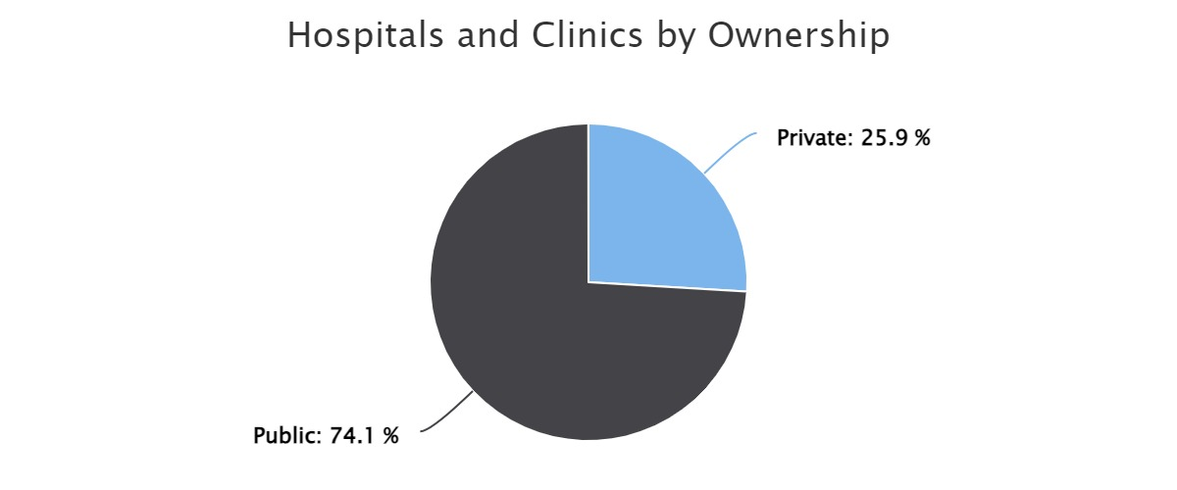

*Figure 1: Hospitals and clinics by ownership. Source: Health Facility Registry (HFR) of the Federal Ministry of Health (FMoH) ) (Source:* [*https://hfr.health.gov.ng/*](https://hfr.health.gov.ng/)*)*

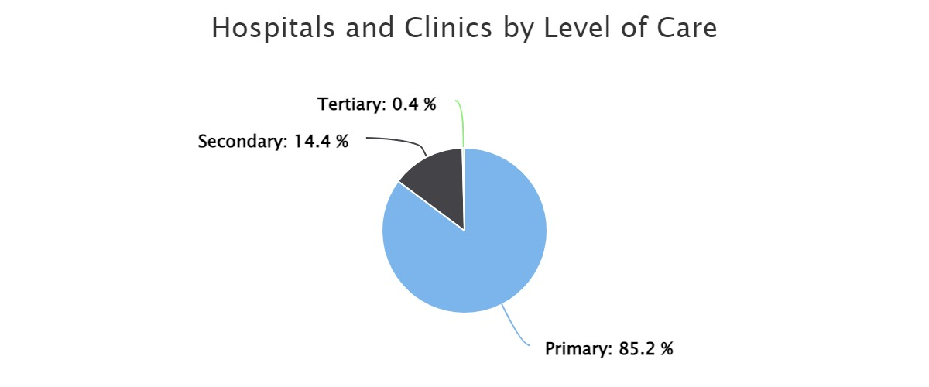

*Figure 2: Hospitals and clinics by level of care. Source: Health Facility Registry (HFR) of the Federal Ministry of Health (FMoH)*

Distribution of Health Facilities as of 2015

|  |  |  |  |
| --- | --- | --- | --- |
| **Type of facility** | **Public** | **Private** | **Total** |
| PHC | 21,808 | 8920 | 30,098 |
| Secondary facility | 969 | 3,023 | 3,992 |
| Tertiary facility | 76 | 10 | 86 |
| **Total** | **22.853** | **11,323** | **34,176** |

*Table 1: National strategic health development plan II (2018-2022)*

The private health industry in Nigeria comprises a diverse array of providers, such as:

* + Hospitals: Serving a range of needs and financial constraints, from small clinics to specialized multispecialty hospitals.
  + Diagnostic centres: providing laboratory and cutting-edge imaging services.
  + Pharmacies: Providing prescription drugs and other pharmaceutical items.
  + Ambulatory care centres: offering procedures and consultations for outpatients.
  + Allied health professionals: Providing mental health services, nutrition counselling, and physiotherapy.

The great majority of enterprises operating in Nigeria's private health sector are small and medium-sized enterprises (SMEs) (Alubo, 2001). Health facilities owned by the government outnumber those owned by private companies (67% vs. 33%) (PharmAccess Foundation, 2022). In comparison to the southern portion of the country, the northern portion has a substantially higher ratio of public to private healthcare facilities (Ogunbekun et al., 1999).

It is difficult to ascertain the size of the private healthcare sector in Nigeria since a sizeable number of existing health facilities are believed to be operating without appropriate licensure by State Ministries of Health (SMOHs) (PharmAccess Foundation, 2022).

The private sector is essential to:

* + Increasing access to healthcare by offering a variety of options and delivering services in underserved areas.
  + Raising the standard of healthcare: Investing in cutting-edge equipment and knowledgeable staff (Adamu & Oche, 2013).
  + Promoting medical innovation by bringing in fresh tools and approaches to care.
  + Creating job opportunities: Supporting companies and creating jobs for medical professionals. Arah et al. (2018) point out that the private sector makes a substantial contribution to both GDP and employment, estimating that it employs over 2 million people and contributes more than 5% of GDP.
  + Bringing in money for the government: Paying taxes and making economic contributions.

## 2. Historical context

### 2.1 Early Origins: Missionary Roots and Colonial Seeds (1800s-1960s)

In Nigeria, the colonial era sowed the seeds for private medical practice. European missionaries founded

missionary clinics and hospitals, mainly to serve their communities and provide a limited range of services to the surrounding populace. Despite their scarcity, these early institutions served as a foundation for later advancements (Ogunbekun et al., 1999).

Expanding public healthcare was given top priority by the newly established government after gaining independence in 1960. Nonetheless, limited resources and an increase in the number of people living in cities made room for private practitioners. Many of the first private physicians were educated in missionary schools or overseas, and they founded small clinics or solo practices that specialized in general medicine. Private pharmacies also began to open during this time, bridging the gap in the supply of medications.

### 2.2 Boom and Bust: Navigating Growth and Uncertainty (1970s-1990s)

The 1970s witnessed a boom in the private medical sector, fuelled by:

* Oil revenue boom: Increased government spending bolstered healthcare infrastructure, creating opportunities for private investment.
* Urbanization: Growing urban populations demanded more accessible and diverse healthcare options.
* Dissatisfaction with public healthcare: Patients who were dissatisfied with public healthcare were influenced to seek private providers due to a lack of resources and perceived deficiencies in the services.

Around this time, bigger private clinics and hospitals were built, drawing in highly qualified workers with their specialized services. The 1980s and 1990s economic downturn, however, affected the industry and caused closures and stagnation. Different Nigerian regions evolved to have different proportions of private to public health facilities (PharmAccess Foundation, 2015).

In Lagos State, which houses the largest number of private hospitals, two out of every five beds were situated in the private sector by 1991 (Alubo, 2001). Just as in Lagos, other states surveyed namely, Oyo, Imo, Anambra, and Kaduna (which accounted for about 80% of the total number of registered facilities and beds at the end of the 20th century) showed similar concentration of private medical practices in industrial and commercial areas (Adeloye et al., 2017).

These differences in the distribution of public and private healthcare facilities emphasize how crucial it is to comprehend regional dynamics when evaluating Nigeria's healthcare system.

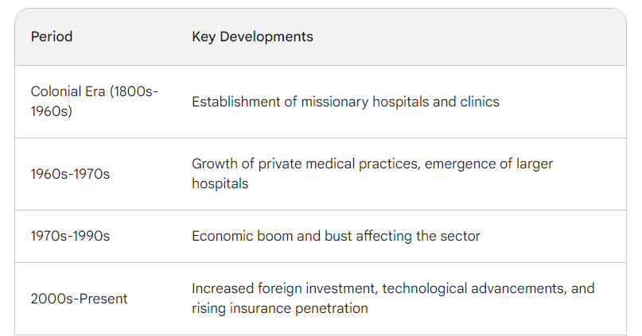

*Table 2: Evolution of private medical practice in Nigeria. Source: Alubo, O. (2001). The promise and limits of private medicine: health policy dilemmas in Nigeria*

## 3. Significant developments and trends

### 3.1 The New Millennium: Rise of Specialized Healthcare and Regulatory Challenges (2000-present)

For Nigerian private medical practice, the twenty-first century marked the start of a new era. Nigeria had an estimated 134,000 hospital beds in 2014, which is significantly less than the average for the African continent (0.8 beds per thousand people). According to data from successive Nigerian Demographic and Health Surverys, hospital bed numbers are estimated to have increased at a compound annual growth rate (CAGR) of 3.8% since 2009, which is somewhat faster than population growth but not at a pace that will significantly affect the population-bed ratio (PharmAccess Foundation, 2015).

Demand for healthcare services in Nigeria is projected to increase, over 5 years, from US$15 billion in 2018 to over US$18 billion in 2023 (PharmAccess Foundation, 2022).

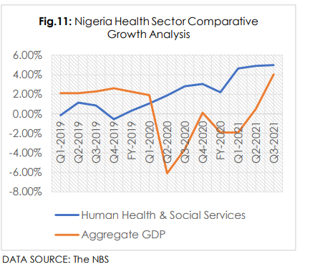

*Figure 4: Nigeria health sector comparative growth analysis. Source: Nigerian Bureau of Statistics (NBS)*

Comparatively speaking, the health sector outperformed the overall economy in terms of real GDP growth as a result of the COVID-19 pandemic. As shown in Fig. 2 above, this development became apparent starting in Q2 2020. While the overall economy shrank from a growth rate of 2.6% in Q4 2019 to -6.1% at the end of Q2 2020, the sector increased from -0.56% at the end of Q4 2019 to 1.89% at the end of Q2 2020 (PharmAccess Foundation, 2022).

Key developments included:

* Increased foreign investment: Attracted by a growing market and potential for profitability, foreign investors entered the sector, establishing multi-specialty hospitals and diagnostic centres. Interestingly, investment by both public and private players spiked at the turn of the present decade as part of measures to curtail the COVID-19 pandemic as well as address other growing needs in the market.
* Technological advancements: The adoption of new technologies like medical imaging and digital healthcare solutions enhanced service delivery and attracted patients seeking advanced care.
* Focus on specialized care: Increased demand for specialized services led to the emergence of dedicated hospitals and clinics catering to specific areas like cardiology, oncology, and mental health.
* Shortcomings in the public sector: Limited resources and infrastructure push patients towards private providers (Adeloye et al., 2017). The WHO estimates that government health expenditure in Nigeria is just 3.5% of GDP, far below the recommended 6% (WHO, 2018).
* Rise of alternative medicine providers: despite growth in the industry generally, the capacity utilization of private health facilities in Nigeria has been found to be poor, with many facilities operating at less than 50% capacity (NPC/ICF, 2018). This has further pushed consumers to patent medicine providers and alternative care options. Collectively known as patent and proprietary medicine vendors (PPMVs), this has boomed into a huge market especially within the informal sector in spite of obvious concerns, particularly in terms of low health knowledge and poor treatment practices (Adigwe et al., 2022).

However, alongside growth, the sector faced challenges:

* Inequitable service distribution: Rural communities receive inadequate service due to the concentration of private facilities in urban areas. According to research by Afolabi et al. (2015), over 80% of private facilities are located in urban areas, which means that access to these facilities is restricted for rural communities.
* High cost of care: Due to disparities in access, a sizable portion of the population was unable to obtain private healthcare. According to studies by the World Health Organization (2023) and Adebayo (2019), a sizable section of the population still cannot afford private healthcare, which results in unequal access.
* Inadequate regulation: Weak regulatory frameworks and enforcement mechanisms raised concerns about unethical practices and substandard care. Research by Ijaduola et al. (2018) raises concerns about unethical practices, substandard care, and weak regulatory oversight in some private facilities.
* The brain drain of healthcare professionals: Skilled personnel sought better opportunities abroad, impacting service delivery and quality. Studies by Adeyeye and Olaofe (2017) show that qualified healthcare professionals migrate abroad due to better opportunities, impacting service delivery. Thus, it is estimated that **over 2,000 Nigerian doctors migrate annually**.

Furthermore, private facilities seldom forward the SMOH information reflecting health facility case-loads, available personnel, and technologies in any given year. In particular, information on private sector personnel resources is compromised by the fact that a considerable proportion of health workers (especially doctors, pharmacists, radiographers, and laboratory technicians) working in the private sector hold full-time appointments in the public sector (PharmAccess Foundation, 2022).

The limited information available on the private healthcare sector in Nigeria can have several implications for policy-making and resource allocation (NPC/ICF, 2018) relating to:

* Inadequate Planning
* Regulatory Challenges
* Resource Allocation Inefficiencies
* Quality Control
* Market Oversight

In essence, policymakers must fill in the information gaps in the private healthcare sector to improve regulatory frameworks, maximize resource utilization, and make well-informed decisions.

## 

## 3.2 Recent Trends and Future Prospects

According to the Nigeria Health Sector Market Study Report, as of 2019, there were an estimated 39,983 hospitals and clinics in Nigeria. These health facilities are categorized into different types, including government-owned facilities, for-profit private facilities, and faith-based facilities.

Nigeria has a growing private health sector which provides 60% of the health care services

through 30% of the country’s conventional health facilities – this includes not-for-profit services

provided by faith-based and non-governmental organizations; and private-for-profit providers (NSHDP II, 2018).

The table below illustrates the number of public and private hospitals and clinics presently in all the states and the FCT according to data by the Health Facility Registry.

| **State** | **Public** | **Private** | **Total** |
| --- | --- | --- | --- |
| Abia | 760 | 430 | 1190 |
| Adamawa | 817 | 89 | 906 |
| Akwa-Ibom | 545 | 198 | 743 |
| Anambra | 658 | 509 | 1167 |
| Bauchi | 1144 | 111 | 1255 |
| Bayelsa | 259 | 44 | 303 |
| Benue | 1126 | 487 | 1613 |
| Borno | 380 | 47 | 427 |
| Cross River | 1062 | 113 | 1175 |
| Delta | 550 | 271 | 821 |
| Ebonyi | 534 | 185 | 719 |
| Edo | 617 | 425 | 1042 |
| Ekiti | 380 | 155 | 535 |
| Enugu | 612 | 425 | 1037 |
| Gombe | 627 | 62 | 689 |
| Imo | 683 | 514 | 1197 |
| Jigawa | 779 | 16 | 795 |
| Kaduna | 1099 | 321 | 1420 |
| Kano | 1274 | 212 | 1486 |
| Katsina | 1867 | 78 | 1945 |
| Kebbi | 916 | 33 | 949 |
| Kogi | 1003 | 232 | 1235 |
| Kwara | 661 | 333 | 994 |
| Lagos | 415 | 1791 | 2206 |
| Nasarawa | 828 | 219 | 1047 |
| Niger | 1368 | 197 | 1565 |
| Ogun | 642 | 565 | 1207 |
| Ondo | 661 | 163 | 824 |
| Osun | 874 | 197 | 1071 |
| Oyo | 845 | 633 | 1478 |
| Plateau | 997 | 348 | 1345 |
| Rivers | 457 | 129 | 586 |
| Sokoto | 802 | 35 | 837 |
| Taraba | 803 | 141 | 944 |
| Yobe | 567 | 16 | 583 |
| Zamfara | 717 | 30 | 747 |
| FCT | 317 | 278 | 595 |

*Table 3: Distribution of health facilities in Nigeria. Source: Health Facility Registry (HFR) of the Federal Ministry of Health (FMoH), 2019*

Specifically, the report highlights that government-owned facilities are still the most dominant in number, accounting for over 70% of health facilities in the country. However, in terms of access to care, private health facilities have grown to provide almost 40% of services in Nigeria especially at the secondary and tertiary levels

Key trends include:

Extension into underserved areas: Targeted initiatives and expanded government-private partnerships are meant to make private healthcare more accessible in rural areas. According to research by Akinkugbe et al. (2020), a significant proportion of outpatient care is provided by private providers, especially in underprivileged areas with limited access to public facilities. To achieve the global average of 2.7 beds per thousand people in 2019, Nigeria needs 386,000 more beds and $82 billion in investments in healthcare real estate assets. To maintain this ratio, however, Nigeria will need 646,000 more beds by the end of 2035.

There appears to be fewer doctors per capita overall, as indicated by the trend that gradually lowers the doctor-patient ratio. WHO (World Health Organization): WHO estimates that there is one doctor for every 4,691 people in Nigeria based on data from 2020. Compared to the 1:6,000 ratio published in 2003, this represents an improvement. However, other sources have different data on the so-called brain drain (Adamu & Oche, 2013).

Rise in health insurance: More people can afford private healthcare thanks to rising awareness and higher insurance penetration rates.

Quality improvement is the main focus: To address concerns about the quality of care, accreditation programs, and stricter regulatory measures are being implemented. In comparison to public hospitals, Okeke et al. (2016) discovered that private hospitals typically have better equipment, infrastructure, and hygiene standards.

Telemedicine and digital health: Adoption of these technologies is enhancing access to care, particularly in remote areas. (John & Ofoegbu, 2014) report that private providers are more likely to adopt new technologies like telemedicine and digital health solutions.

*Table 4:* Census of patent and proprietary medicine shops in Kaduna and Lagos states, 2018

|  |  |
| --- | --- |
| **Variables** | **Number of shops (%) (N = 8318)** |
| State   * Kaduna * Lagos | * 4572 (55.0) * 3746 (45.0) |
| **Location**   * Urban * Rural | * 6339 (76.2) * 1979 (23.8) |
| Source: <https://www.ncbi.nlm.nih.gov/pmc/articles/PMC8088718/pdf/12960_2021_Article_602.pdf> | |

*Table 5.* Census of patent and proprietary medicine shops, 16 states in Nigeria, 2013–2014

|  |  |
| --- | --- |
| **Variable** | **No. (%) of shops (n = 20 642)** |
| **Registration**   * National Association of Patent and Proprietary Medicine Dealers * Pharmacist Council of Nigeria | * 15 619 (81.4) * 2 565 (13.4) |
| **Location**   * Urban * Rural | * 11 258 (57.3) * 8 399 (42.7) |
| Source: <https://www.ncbi.nlm.nih.gov/pmc/articles/PMC4794299/pdf/BLT.15.154666.pdf> | |

## 

## 4. Looking Forward

The future of private medical practice in Nigeria is promising, yet challenges remain. To ensure sustainable growth and positive impact, the sector requires:

Improved accessibility and affordability: Public-private partnerships, targeted subsidies, and insurance coverage expansion can all help to increase access to private healthcare. Reaching out to rural communities can be encouraged by targeted initiatives and incentives (Afolabi et al., 2015). Increased access to private healthcare can be achieved through public-private partnerships, government subsidies, and expansion of health insurance coverage (Akinkugbe et al., 2020).

Tighter regulation and quality control: To guarantee morally sound and high-quality healthcare, strong regulatory frameworks and enforcement tools are essential. Ensuring ethical and high-quality care requires strong regulatory frameworks and enforcement mechanisms (Ijaduola et al., 2018).

Investment in the development of the healthcare workforce: It's critical to combat brain drain by fostering training programs and attractive work environments. Skilled professionals can be attracted and retained by making investments in the development of the healthcare workforce and designing appealing work environments (Adeyeye and Olaofe, 2017).

Adopting technology: Data-driven methods, digital health platforms, and telemedicine can all be used to increase effectiveness and reach.

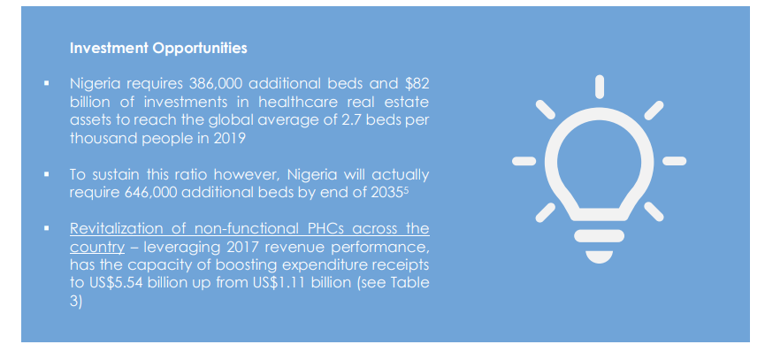

*Figure 5: Investment opportunities in the private health sector. Source: Nigeria Healthcare Market Study Report 2022*

## 5. Conclusion

Technological advancements, government policies, and socioeconomic factors have all influenced the dynamic evolution of private healthcare in Nigeria. Despite its difficulties, the industry has enormous potential to advance healthcare innovation, quality, and access. Private medicine can make a significant contribution to Nigerians' future health and equity by addressing its constraints and seizing opportunities.

One key tactic for interacting with private health companies in Nigeria is to actively participate in trade shows and conferences. For instance, international brands can present their goods and services to prospective partners at the Medic West Africa exhibition (PharmAccess Foundation, 2022).

## References

1. Adamu, H., & Oche, M. (2013). Determinants of patient waiting time in the general outpatient department of a tertiary health institution in North Western Nigeria. *Annals of Medical and Health Sciences Research*, *3*(4), 588. <https://doi.org/10.4103/2141-9248.122123>
2. Adeloye, D., David, R. A., Olaogun, A. A., Auta, A., Adesokan, A., Gadanya, M., Opele, J. K., Owagbemi, O., & Iseolorunkanmi, A. (2017). Health workforce and governance: The crisis in Nigeria. *Human Resources for Health*, *15*(1), 1–8. <https://doi.org/10.1186/s12960-017-0205-4>
3. Adigwe, O. P., Fatokun, O. T., Benefit, E. K., Ibrahim, J. A., Adzu, B., & Isimi, C. Y. (2022). Herbal Medicine Products Sold in Nigeria: A Pilot Survey. *Journal of Complementary and Alternative Medical Research*, *July*, 1–11. <https://doi.org/10.9734/jocamr/2022/v18i430356>
4. Adebayo, O. (2019). The cost of healthcare in Nigeria: A critical analysis. *International Journal of Health Economics and Management*, 17(2), 189-202.
5. Adebayo, O. A., Adebowale, D., & Solagbade, O. M. (2014). Adoption of e-health technologies in private hospitals in Nigeria: Challenges and prospects. *Journal of Public Health*, 19(5), 835-842.
6. Adeyeye, O., & Olaofe, G. (2017). Brain drain of healthcare professionals in Nigeria: Causes, consequences and solutions. *Journal of Public Health Policy*, 38(3), 393-402.
7. Akinkugbe, O. M., Afolabi, M. O., Adebayo, O. A., & Ijaduola, O. (2020). The role of private healthcare providers in expanding access to quality healthcare in Nigeria. *Nigerian Journal of General Practice. 14*(2), 174–181
8. Alubo, O. (2001). The promise and limits of private medicine: health policy dilemmas in Nigeria. *Health Policy and Planning*, *16*(3), 313–321. <https://doi.org/10.1093/heapol/16.3.313>
9. John, A., & Ofoegbu, E. (2014). Issues on E-health Adoption in Nigeria. *International Journal of Modern Education and Computer Science*, *6*, 36–46. <https://doi.org/10.5815/ijmecs.2014.09.06>
10. NPC/ICF. (2018). *Nigeria Demographic and Health Survey 2018. Abuja, Nigeria, and Rockville, Maryland, USA: NPC and ICF; 2019 - Google Search*. <https://www.google.com/search?q=National+Population+Commission+%28NPC%29+%5BNigeria%5D%2C+ICF.+Nigeria+Demographic+and+Health+Survey+2018.+Abuja%2C+Nigeria%2C+and+Rockville%2C+Maryland%2C+USA%3A+NPC+and+ICF%3B+2019&source=hp&ei=mDmjYc77Da-GjLsPwMewIA&ifls>
11. Ogunbekun, I., Ogunbekun, A., & Orobaton, N. (1999). Private Health Care in Nigeria: Walking the Tightrope. *Health Policy and Planning*, *14*(2), 174–181. <https://doi.org/10.1093/heapol/14.2.174>
12. PharmAccess Foundation. (2015). Nigerian Health Sector Market Report. *PharmAccess Foundation*, *March*. <https://www.rvo.nl/sites/default/files/Market_Study_Health_Nigeria.pdf>
13. PharmAccess Foundation. (2022). *Nigeria Health Sector Market Study Report*. <https://www.pharmaccess.org/wp-content/uploads/2023/02/Nigeria-Healthcare-Market-Study-10-Case-StudiesProviders-link_Final-Report_2022.docx.pdf>

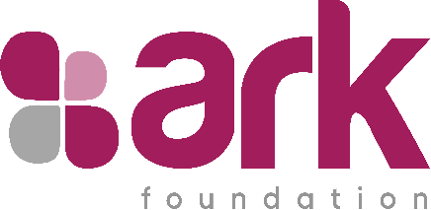

**CHORUS is funded by UK aid from the British people. However, the views expressed do not necessarily reflect the UK government’s official policies.**

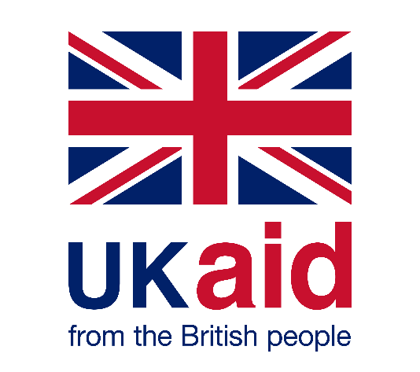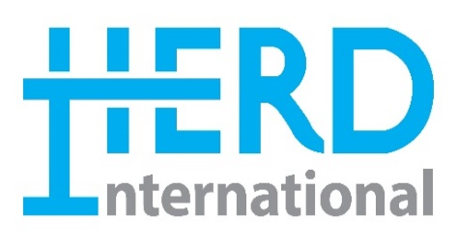

**OUR PARTNERS:**

